CERTIFICATE OF COMPLETION

This is to certify that:

Mr/Mrs ………….
has completed the whole course
within the project
„Money & Life Skills – Financial Capability Made Easy”
on …………..……….
(date)

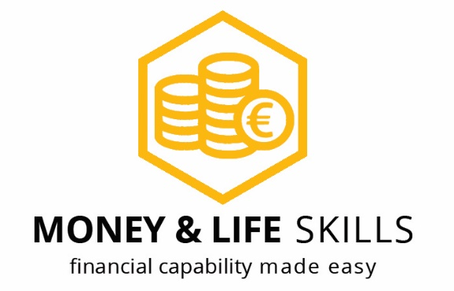 | ……………………………………………..…..….  (name of trainer)  ……………………………………………..…..….  (stamp and signature of trainer)

……………………………………………..…..….
(place, date)

